Current collector unit
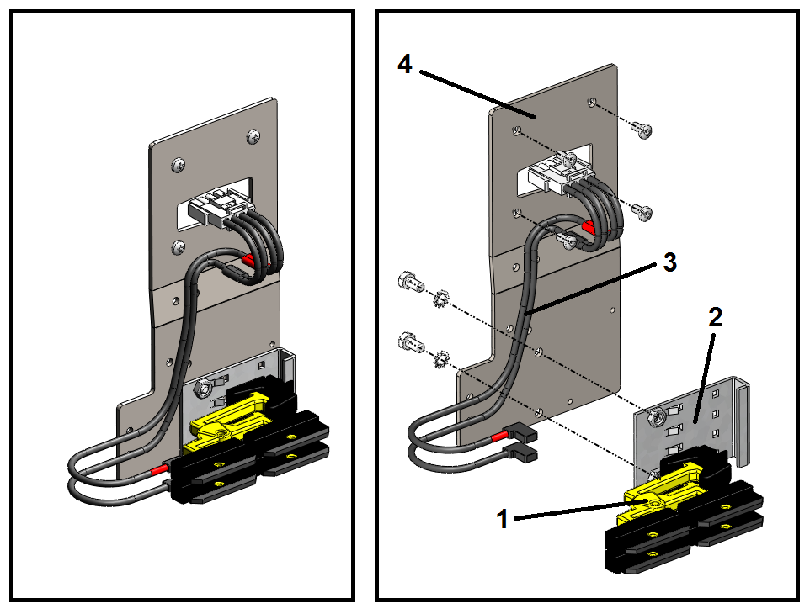
Fig. 1-1 Current collector unit, complete
1. | Brush | 3. | Current collector cable
2. | Support plate for brush | 4. | Bracket for securing current collector

Preparation necessary
The current collector units must be mounted on the tilting devices before the tilting devices are mounted on the train of carts.

Tools
Supplied Customer Tool List TT/CB 4000

Installation guide

Installation of current collector unit on tilting device
.1 Mount the current collector unit on the right-hand side of the tilting device (as seen in the direction of travel) with the four screws provided as shown in Fig. 1-2.
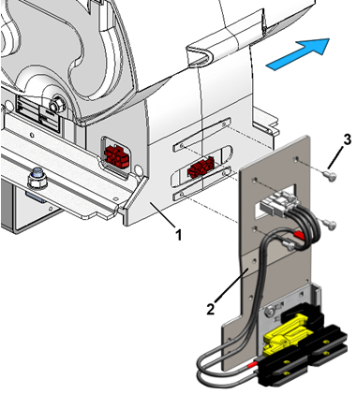
Fig. 1-2 Installation of current collector unit on tilting device
1. | Tilting device
2. | Current collector unit
3. | Screw, Sheet Metal, Phillips, #10x5/8"

.2 Plug the current collector cable into the socket on the tilting device as shown in Fig. 1-3.
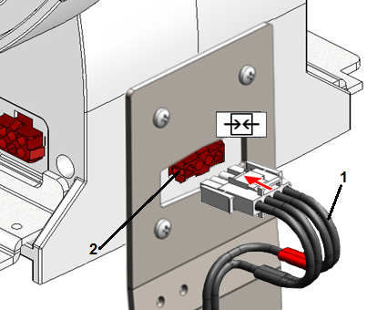
Fig. 1-3 Connection of current collector cable
1. | Current collector cable
2. | Socket for current collector cable on tilting device

.3 Secure the current collector cable to the bracket with a cable tie as shown in Fig. 1-4.
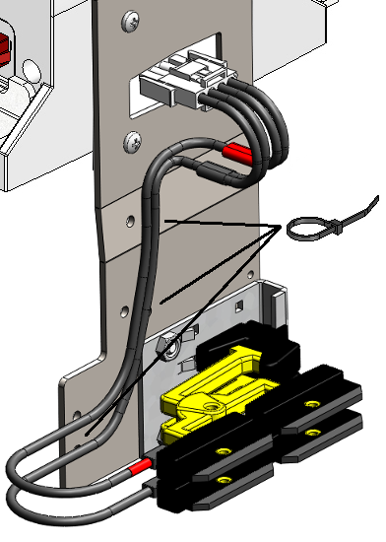
Fig. 1-4 Attachment of current collector cable

Positioning of tilting devices with current collector
The tilting devices with current collector units fitted have to be positioned at certain intervals.
The size of the intervals depends partly on the carriage pitch and partly on the total number of carts.
Design rules:
The following design rules must be complied with when positioning current collector units:
1. A current collector unit must not be positioned on cart no. 1 in the train of carts, as this position is reserved for the reflector for synchronization photocell.
2. The interval between two current collector units must not vary by more than one cart pitch over the entire sorter.
For a cart pitch of 800 mm, for example, the standard interval between the current collector units is nine cart pitches (see Table 1-1). This means that the intervals will be nine cart pitches (principal rule) in some places and eight cart pitches in others so as to tally with the total number of carts.
In order to achieve this, the number of standard intervals and adjustment intervals has to be calculated in accordance with the following rules:

Calculation rules:
The following quantities are used to calculate the position of the current collectors:
n | = | Number of carts in the sorter
Cp | = | Cart pitch
X_{standard} | = | Standard interval between two consecutive current collectors measured in whole cart pitches
X_{adjust} | = | Adjustment interval between two consecutive current collector units
Z | = | Number of current collector units in the sorter
Z_{standard} | = | Number of standard intervals (X_{standard})
Z_{adjust} | = | Number of adjustment intervals (X_{adjust})

.1 Calculate the standard interval (X_{standard}) as shown in Equation 1-1 and the adjustment interval (X_{adjust}) as shown in Equation 1-2.
X_{standard} = (length of clear conductor rail – length of current collector brush)/Cp
⇓
X_{standard} = (7813 - 110)/Cp = 7703/Cp ↓ (rounded down to whole number)
Equation 1-1 Calculation of standard interval

X_{adjust} = X_{standard} -1
Equation 1-2 Calculation of adjustment interval

X_{standard} and X_{adjust} are given in Table 1-1 for the possible cart pitches.
Table 1-1 Interval between current collector units
Cart pitch (Cp): | 500 | 600 | 700 | 800 | 900 | 1000 | 1100 | 1200
X_{standard}: | 15 | 12 | 11 | 9 | 8 | 7 | 7 | 6
X_{adjust}: | 14 | 11 | 10 | 8 | 7 | 6 | 6 | 5

.2 Calculate the number of current collector units (Z) needed in the sorter as shown in Equation 1-3.
Z = n / X_{standard} ↑ (rounded up to whole number)
Equation 1-3 Calculation of number of current collector units in complete sorter

.3 Calculate the number of adjustment intervals Z_{adjust} between current collector units in the sorter as shown in Equation 1-4.
Z_{adjust} = (Z ● X_{standard}) - n
Equation 1-4 Calculation of number of adjustment intervals

.4 Calculate the number of standard intervals Z_{standard} between current collector units in the sorter as shown in Equation 1-5.
Z_{standard} = Z - Z_{adjust}
Equation 1-5 Calculation of number of standard intervals
Example calculation:
Number of carts in sorter (n) = 246
Cart pitch (Cp) = 800 mm
.1 X_{standard} = 9 cart pitches (taken from Table 1-1)
X_{adjust} = 8 cart pitches (taken from Table 1-1)

.2 Z = n / X_{standard} = 246 / 9 = 27.33 = 28 current collector units (rounded up to whole number)

.3 Z_{adjust} = (Z ● X_{standard}) - n = (28 ● 9) - 246 = 6 adjustment intervals

.4 Z_{standard} = Z - Z_{adjust} = 28 - 6 = 22 standard intervals

In the above example the first 23 current collector units (= 22 standard intervals) have to be installed with an interval of nine cart pitches. The remaining five current collector units (= 6 adjustment intervals) should be installed with an interval of eight cart pitches.

